

Sharmistha Dey



**CHAPTER 1**

1. **What is the best way to structure a website?**
2. **<!DOCTYPE html>-**

The <!DOCTYPE [html](https://html.com/)> declaration is used to inform a website visitor's browser that the document being rendered is an HTML document. While not actually an HTML element itself, every HTML document should being with a DOCTYPE declaration to be compliant with HTML standards.

1. **<html>..</html>-**

The **HTML**<html>**element** represents the root (top-level element) of an HTML document, so it is also referred to as the root element*.*

1. **<head>..</head>-**

The [HEAD](https://www.w3.org/TR/html401/struct/global.html#edef-HEAD) element contains information about the current document, such as its title, keywords that may be useful to search engines, and other data that is not considered document content. User agents do not generally render elements that appear in the [HEAD](https://www.w3.org/TR/html401/struct/global.html#edef-HEAD) as content. They may, however, make information in the [HEAD](https://www.w3.org/TR/html401/struct/global.html#edef-HEAD) available to users through other mechanisms.

1. **<meta>-**

Information about a document rather than document content in a variety of ways.

1. **<title>..</title>-**

The TITLE element is not considered part of the flow of text. It should be displayed, for example as the page header or window title. Exactly one title is required per document.

1. **<body>..</body>-**

The body of a document contains the document's content. The content may be presented by a user agent in a variety of ways. For example, for visual browsers, you can think of the body as a canvas where the content appears: text, images, colors, graphics, etc. For audio user agents, the same content may be spoken.

1. **<style>..</style>-**

The **HTML**<style>**element** contains style information for a document, or part of a document. It contains CSS, which is applied to the contents of the document containing the <style> element.

1. **<header>..</header>-**

Headers may be oriented to give the hierarchy of a section in the context of the page.

1. **<div>..</div>-**

The <div> tag nothing more than a container unit that encapsulates other page elements and divides the html document into sections.



1. **<nav>..</nav>-**

It defines a section of navigation links (i.e. links to other pages or to parts within the page itself) in a document.

1. **<section>..</section>-**

It defines a section of a document, such as header, footer etc.

1. **<iframe..</iframe>-**

It defines an inline frame that contains external objects including other web page.

1. **<footer>..</footer>-**

The <footer> element is the last of what I consider the essential section elements.

1. **<script>..</script>-**

It is used to embed or reference an executable client-side script (such as JavaScript) within an HTML or XHTML document.

1. **Suggest two different layouts to you recommend for Xenonstack and Akira AI with pros and cons of each.**
2. **Layout-**

The layout should be designed taking into account the inter-relationships between various equipment, departments and personnel.

A well-made HTML layout improves user experience in two significant ways:

* Simplifies navigation by clarifying the structure
* Makes the design more visually appealing

**Grid of Cards-**

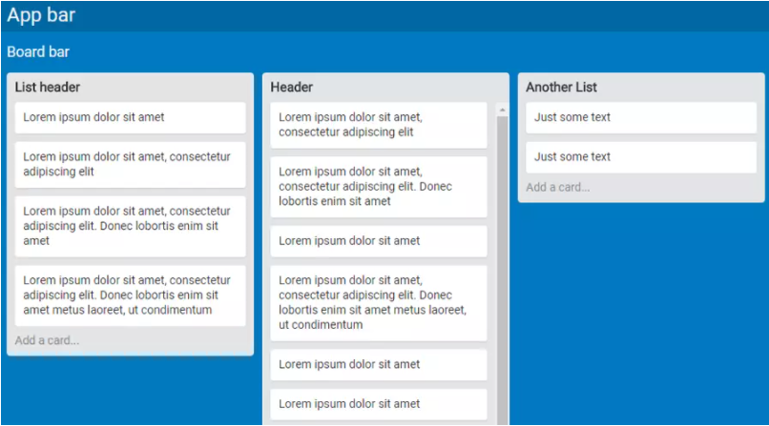



**Z Shape-**

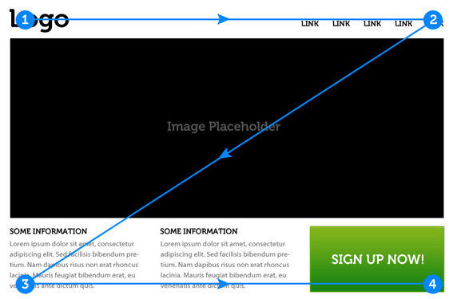

1. **Nav Bar-**

It represents a section of a page whose purpose is to provide navigation links either within the current document or to the other documents.

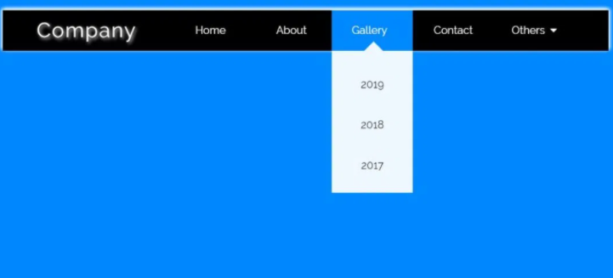

1. **Good Design-**

Doing well designed and neat, clean.